Requirement Analysis

Group ICT1.K62.20201-09

* Trần Hải Sơn - 20176861
* …

# Use case diagram

## General use case diagram

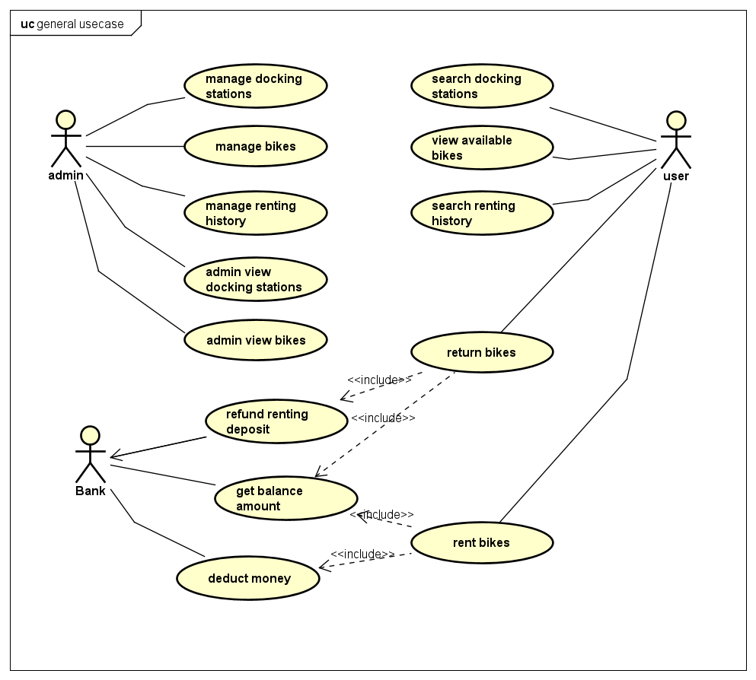

## Use case diagram for “Rent bikes”

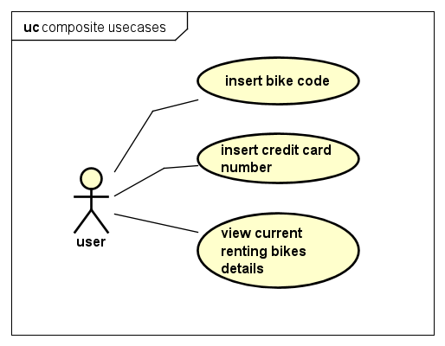

# Use case specification

## Use case “Insert bike code”

|  |  |  |  |
| --- | --- | --- | --- |
| **Use case code** | UC001 | **Use case name** | Insert bike code |
| **Actor** | User | | |
| **Precondition** | No | | |
| **Main flow of event**  **(success)** | |  |  |  | | --- | --- | --- | | No | Doer | Action | | 1. | User | Press "Rent Bike" button. | | 2. | System | Display dialog to enter bike code. | | 3. | User | Enter bike code (description below *). | | 4. | User | Request for bike (press submit button). | | 5. | System | Check if bike code is empty or not. | | 6. | System | Check if bike code is valid or not. | | 7. | System | Check if bike has already been rented or not. | | 8. | System | Prompt user and move to another screen to show state when renting bike. | | | |
| **Alternative flow of event** | |  |  |  | | --- | --- | --- | | No | Doer | Action | | 5a. | System | Error: bike code is empty. | | 6a. | System | Error: bike code is invalid. | | 7a. | System | Error: bike has been rented. | | | |

* Bike code requirement.

|  |  |  |  |  |  |
| --- | --- | --- | --- | --- | --- |
| No | Input | Description | Compulsory? | Valid condition | Example |
| 1. | Bike code | Each bike has a unique code. User must enter bike code to rent bike. | Yes | Bike code must be same with valid code in the system | EBIKE0001 |